An advisory commission of the Coastal Protection and Restoration Authority
cOASTAL LOUISIANA LEVEE CONSORTIUM

Amite River Basin Drainage and Water Conservation District

Atchafalaya Basin Levee District

Office of the Governor-Coastal Activities

Chenier Plain Coastal Restoration & Protection Authority

Grand Isle Independent Levee District

Iberia Parish Levee District

Jefferson Davis Parish Government

Lafitte Area Independent Levee District

Lafourche Basin Levee District

Non-Flood Protection Asset Management Authority

North Lafourche Conservation, Levee and Drainage District

Plaquemines Parish Government

Pontchartrain Levee District

The Sewerage and Water Board of New Orleans

South Lafourche Levee District

Southeast Louisiana Flood Protection Authority—East

Southeast Louisiana Flood Protection Authority—West

St. Mary Levee District

St. Tammany Levee District

Terrebonne Levee and Conservation District

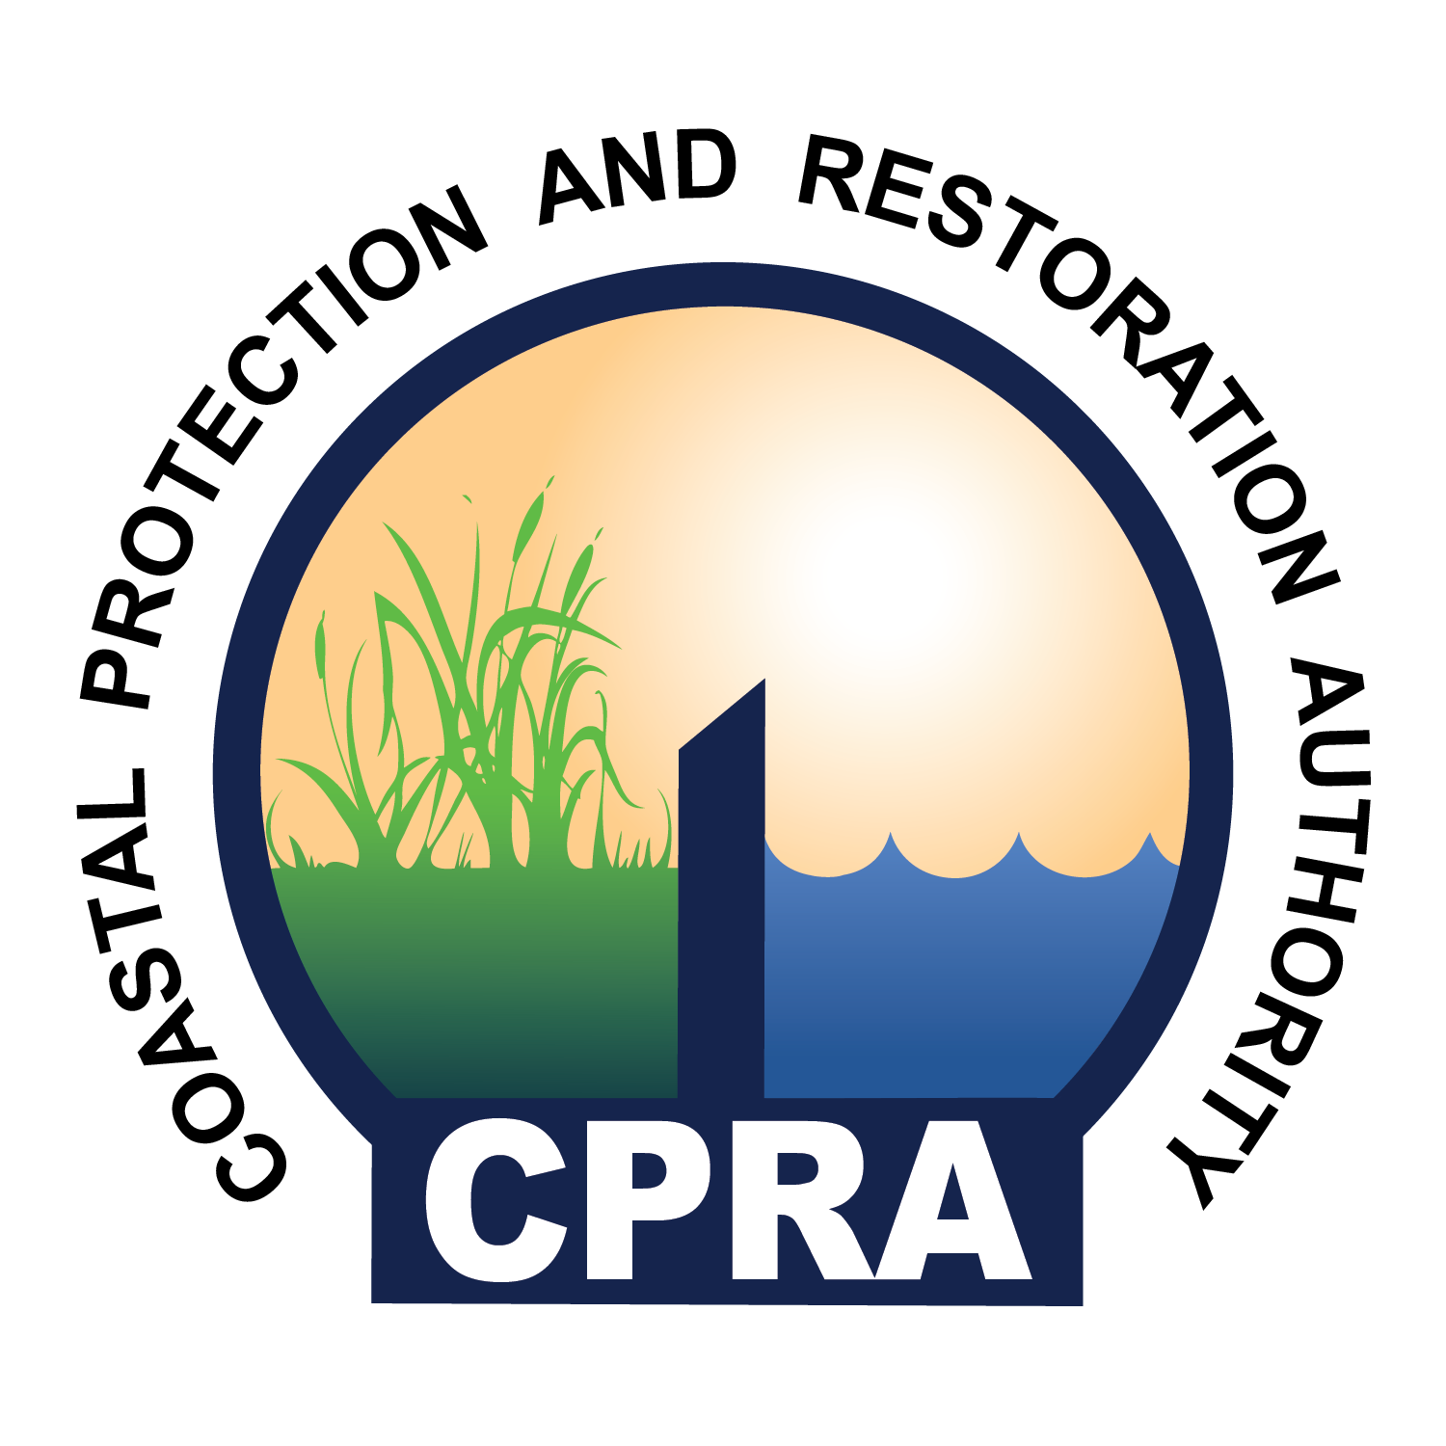

900 North Third St. 4th Floor
Baton Rouge, LA 70802
Coastal Louisiana Levee Consortium Meeting
Capital Building, PRESS ROOM – 4th Floor
900 North Third Street
Baton Rouge, LA 70802

September 28, 2016
09:30 A.M.

- Call to Order – Windell Curole
- Roll Call
- Approval of Agenda
- Approval of Minutes
- Operations and Maintenance costs for New Orleans area Federal Flood
Protection System – Guy McInnis
- Needed Legislation – Reggie Dupre, TLCD
- 2016 Flood and the Comite Diversion– Dietmar Rietschier
- NFIP Update – Dwayne Bourgeois, NLLD
- Protecting the Chenier Plain (Video) – Nedra Davis
- Public Comment
- Adjourn

